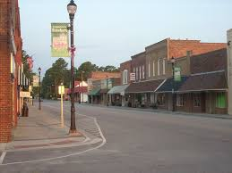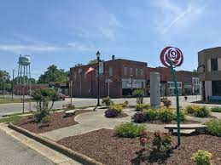
Invest in Downtown Roseboro
Roseboro Demographics-Claritas 2023
5-Mile Radius 20-Minute Drive time
Median Household Income $50,505 $57,655
Average Household Income $66,255 $73,576
Highest Income Segment $50,000-$74,999 (17.7%) $50,000-$74,999 (17.7%)
% earning above $50,000 49.5% 49.7%
% earning below $50,000 50.4% 50.1%

Retail Gaps (Business escaping to neighboring communities-AGS Data)
Category 5-Mile Radius 20-Minute Drive Time
Total Food and Drink $5,226,626 $ 9,512,233
Electronics and Appliances $ 828,779 $ 1,135,236
Lawn and Garden Equipment $ 329,113 --------------
Groceries $5,802,496 $ 6,100,379
Beer, Wine, Liquor $ 304,233 $ 1,129,667
Clothing $1,707,367 $ 4,146,292
Shoes $ 386,261 $ 1,851,320
Jewelry/Luggage/Leather Goods $ 187,990 $ 909,284
Sporting Good/Hobbies $ 627,752 $ 1,816,190
Book Stores $ 166,475 $ 804,038
General Merchandise $5,532,238 $12,241,764
Office Supplies/Stationary $ 218,821 $ 200,665

Available Properties

For more information, contact Roseboro Mayor Alice Butler at 910-525-4121 and roseboromayor@gmail.com

